SIMATS ENGINEERING
ASSESSMENT TOOL 3

COURSE NAME: COMPUTER NETWORKS COURSE CODE: CSA0713

COURSE OUTCOME COVERED
CO2: Configure IP addressing schemes, subnetting, and basic routing techniques using
simulation tool, for efficient network design and topology. (BL3)

Assessment Tool Weightage: 30%

Dr.V.Parthipan

Annexure A
Debugging &amp; Optimisation Task

Code of Conduct:
I A sreenath (192525119) (Name / Reg No) certify that this submission is my original work
and that I have adhered to the guidelines specified for this assessment.
I understand that any violation of academic integrity rules will result in disciplinary action.

Signature of the student: A sreenath

1. A rapidly growing IT company has shifted its operations to a newly constructed six-
storey smart office building. More than 1,200 employees use wireless laptops,
smartphones, IP phones, printers, and IoT devices connected through the company&#39;s
Wireless Local Area Network (WLAN). The office relies heavily on cloud computing,
online meetings, video conferencing, and file sharing, making uninterrupted wireless
connectivity essential for daily operations. In addition, the company has a team of field
engineers and sales executives who travel across different cities and use 4G/5G Wireless
Wide Area Network (WWAN) services to access the company&#39;s servers, customer
databases, and business applications from remote locations.
During the last few weeks, employees have reported several connectivity issues. Users
experience slow internet speeds during peak working hours, frequent Wi-Fi
disconnections while moving between floors, and weak wireless signals in conference
rooms. Video conferencing applications often freeze or disconnect, affecting
communication with international clients. Network administrators have also observed that
some wireless access points are overloaded while others remain underutilized, leading to
uneven traffic distribution. Furthermore, field engineers working in rural and highway
areas frequently lose WWAN connectivity, delaying the upload of maintenance reports
and customer information. Security audits reveal that a few wireless devices are still
connected using outdated security protocols, exposing sensitive company information to
potential cyber threats. The management has requested the network engineering team to
investigate these issues, identify the root causes, and optimize both the WLAN and
WWAN infrastructure to ensure high performance, secure communication, and seamless
connectivity for all users.
Sol..
1️⃣ WLAN Debugging Tasks (Smart Office Building)
A. Connectivity & Performance Analysis
- Conduct a site survey using Wi-Fi analyzers (e.g., Ekahau, NetSpot) to map signal strength and identify dead zones.
- Check Access Point (AP) load distribution — identify overloaded APs and underutilized ones.
- Monitor bandwidth usage during peak hours to detect congestion or bottlenecks.
- Analyze roaming behavior — verify if devices are properly switching APs when moving between floors.
- Inspect interference sources (microwave ovens, Bluetooth devices, thick walls, metal structures).
B. Configuration & Optimization
- Reconfigure AP channels to minimize overlap (use non-overlapping channels 1, 6, 11 for 2.4 GHz; dynamic channel assignment for 5 GHz).
- Enable band steering to shift capable devices to 5 GHz for higher throughput.
- Implement load balancing across APs to distribute clients evenly.
- Upgrade firmware on all APs to ensure stability and compatibility.
- Adjust transmit power to balance coverage and prevent interference between floors.
C. Security Enhancements
- Disable outdated protocols (WEP, WPA) and enforce WPA3 or WPA2-Enterprise with RADIUS authentication.
- Segment guest and internal networks using VLANs.
- Enable MAC filtering and device profiling for IoT devices.
- Regularly audit connected devices for unauthorized access.
2️⃣ WWAN Debugging Tasks (Field Engineers & Sales Teams)
A. Connectivity & Coverage
- Analyze WWAN signal strength and coverage maps for rural/highway areas.
- Identify carrier dead zones and consider multi-SIM or multi-carrier routers for redundancy.
- Monitor latency and packet loss during remote sessions.
- Check device firmware and modem drivers for compatibility with 4G/5G networks.
B. Optimization
- Implement VPN acceleration for secure remote access with minimal latency.
- Use adaptive bandwidth management to prioritize critical applications (e.g., maintenance uploads).
- Deploy edge caching or local data sync to reduce dependency on real-time connectivity.
- Enable automatic failover between 4G and 5G networks.
C. Security
- Enforce end-to-end encryption for all WWAN communications.
- Use mobile device management (MDM) to ensure compliance with security policies.
- Regularly update mobile apps and VPN clients to patch vulnerabilities.
3️⃣ Network-Wide Optimization Recommendations
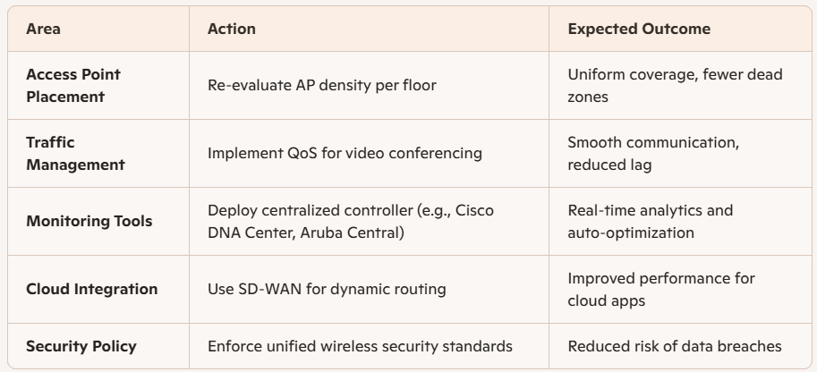
4️⃣ Root Cause Summary
- Uneven AP load → poor traffic distribution
- Weak signal in conference rooms → insufficient AP coverage
- Outdated security protocols → vulnerability exposure
- WWAN dropouts → poor rural coverage and lack of redundancy
5️⃣ Outcome Goals
- Seamless roaming between floors
- Balanced AP utilization
- Stable WWAN connectivity for remote teams
- Secure, high-performance wireless communication across all environments
2. A multinational financial organization operates its headquarters, regional offices, and
multiple data centers using an Asynchronous Transfer Mode (ATM) network to support
mission-critical services such as online banking, video conferencing, Voice over IP (VoIP),
and real-time financial transactions. The ATM network uses fixed-size 53-byte cells and
establishes Virtual Circuits (VCs) to provide reliable and predictable Quality of Service
(QoS). Recently, the organization has experienced several performance issues during peak
business hours. Customers report delays in online transactions, voice calls suffer from jitter
and occasional packet loss, and video conferencing sessions experience reduced quality.
Network monitoring indicates that several ATM switches are operating at high utilization,
some Virtual Circuits are congested, and available bandwidth is not being efficiently
allocated among different traffic classes. Engineers also discover that certain applications
are using inappropriate ATM service categories, leading to increased delay and inefficient
resource utilization. The IT department has assigned you as the network engineer to
investigate the ATM network, identify the faults, debug the performance issues, and
recommend optimization strategies to restore efficient, reliable, and high-quality
communication across the enterprise.
Sol…
1️⃣ ATM Network Debugging Tasks
A. Performance & Utilization Analysis
- Monitor ATM switch utilization using SNMP or network management tools to identify overloaded switches.
- Check Virtual Circuit (VC) statistics — look for high cell loss, delay, or congestion indicators.
- Analyze traffic patterns during peak hours to determine which applications consume excessive bandwidth.
- Inspect buffer usage on ATM switches to detect queue buildup or cell discards.
- Verify end-to-end latency for real-time services (VoIP, video conferencing, transactions).
B. Fault Identification
- Congested VCs: Some circuits may be oversubscribed or misconfigured, causing delay and jitter.
- Incorrect service categories: Applications using unsuitable ATM service types (e.g., CBR for non-real-time traffic) waste bandwidth.
- QoS misconfiguration: Priority queues may not align with traffic class requirements.
- Bandwidth allocation imbalance: Certain traffic classes may monopolize resources, starving others.
2️⃣ Optimization Strategies
A. Traffic Engineering
- Reassign ATM service categories appropriately:
- Implement traffic shaping and policing at ingress points to control bursty traffic.
- Enable Weighted Fair Queuing (WFQ) or similar scheduling to ensure fair bandwidth distribution.
- Use Explicit Forward Congestion Notification (EFCN) to signal congestion before cell loss occurs.
B. QoS Optimization
- Reconfigure QoS parameters (PCR, SCR, MCR) to match application requirements.
- Prioritize real-time traffic (voice/video) using higher QoS classes.
- Adjust buffer thresholds to prevent jitter and packet loss.
- Enable adaptive rate control for variable bit rate services.
C. Network Resource Management
- Redistribute load across ATM switches to balance utilization.
- Upgrade switch capacity or interconnect bandwidth where persistent congestion occurs.
- Implement dynamic VC routing to reroute traffic around congested paths.
- Regularly audit VC configurations to ensure optimal resource allocation.
3️⃣ Security & Reliability Enhancements
- Enable traffic encryption for sensitive financial transactions.
- Deploy redundancy (dual VCs, backup paths) for critical services.
- Implement proactive monitoring with alerts for latency, jitter, and cell loss thresholds.
- Schedule maintenance windows to update firmware and optimize switch configurations.
4️⃣ Root Cause Summary
- Overloaded ATM switches → high utilization and delay
- Misconfigured service categories → inefficient bandwidth use
- Poor QoS prioritization → jitter and packet loss in real-time traffic
- Static VC allocation → congestion during peak hours
5️⃣ Expected Outcomes
- Balanced bandwidth allocation across traffic classes
- Reduced latency and jitter for voice/video services
- Improved transaction speed and reliability
- Efficient utilization of ATM network resources
- Restored high-quality communication across all sites
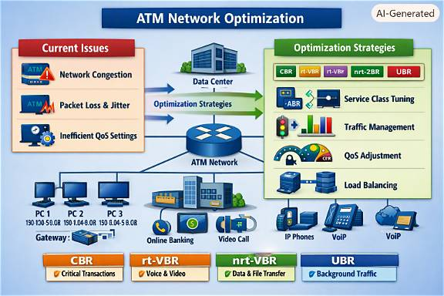

3. A multinational e-commerce company has interconnected its headquarters, regional offices,warehouses, and cloud data centers using a Multiprotocol Label Switching (MPLS)
network to ensure fast, secure, and reliable communication. The MPLS infrastructure
supports critical business applications, including online order processing, enterprise
resource planning (ERP), video conferencing, Voice over IP (VoIP), cloud-based inventory
management, and real-time customer support. Recently, the organization has experienced
frequent performance issues during peak business hours. Employees report slow access to
cloud applications, delayed order processing, poor-quality voice calls, and interruptions
during video conferences. Network monitoring reveals that some Label Switched Paths
(LSPs) are heavily congested, while other paths remain underutilized. The IT team also
discovers that several routers have incorrect label mappings, causing inefficient routing and
increased latency. In addition, traffic engineering has not been properly configured,
resulting in uneven bandwidth utilization across the MPLS backbone. Since these issues are
affecting customer satisfaction and business operations, the network administrator has
asked you to investigate the MPLS network, identify the faults, debug the performance
problems, and recommend suitable optimization techniques to improve the overall
efficiency and reliability of the network.
Sol…
1️⃣ MPLS Network Debugging Tasks
A. Performance & Congestion Analysis
- Monitor Label Switched Path (LSP) utilization using MPLS traffic engineering tools (e.g., NetFlow, SNMP, or Cisco NBAR).
- Identify congested LSPs and underutilized paths — analyze bandwidth distribution across the backbone.
- Check latency and jitter metrics for real-time applications (VoIP, video conferencing).
- Inspect router CPU and memory utilization to detect overloads affecting label processing.
- Verify label mappings — ensure correct Label Distribution Protocol (LDP) or Resource Reservation Protocol (RSVP-TE) configurations.
B. Fault Identification
- Incorrect label mappings → inefficient routing and increased latency.
- Uneven LSP utilization → congestion on some paths while others remain idle.
- Missing or misconfigured traffic engineering (TE) → poor bandwidth allocation.
- QoS misalignment → low priority for critical applications during peak hours.
2️⃣ Optimization Strategies
A. Traffic Engineering (TE)
- Enable MPLS-TE to dynamically reroute traffic based on bandwidth and latency.
- Configure explicit LSP paths for critical applications (ERP, order processing).
- Implement auto-bandwidth adjustment to resize LSPs according to real-time demand.
- Use constraint-based routing to balance load across multiple paths.
B. Label Management
- Audit label bindings and refresh LDP/RSVP sessions to correct mismatches.
- Deploy hierarchical LSPs for scalability across data centers and regional offices.
- Enable fast reroute (FRR) for quick recovery during link failures.
C. QoS Optimization
- Classify traffic into priority levels:
- Apply QoS policies at ingress routers to ensure fair bandwidth allocation.
- Enable Weighted Random Early Detection (WRED) to prevent queue overflow.
D. Network Resource Management
- Redistribute traffic load across LSPs using dynamic routing.
- Upgrade backbone links or router interfaces where persistent congestion occurs.
- Deploy centralized MPLS controller for real-time path optimization.
- Implement redundancy with backup LSPs for critical services.
3️⃣ Security & Reliability Enhancements
- Use MPLS VPNs for secure segmentation between departments and data centers.
- Enable encryption for sensitive customer and transaction data.
- Deploy monitoring and alert systems for latency, packet loss, and label errors.
- Schedule periodic audits of TE and QoS configurations.
4️⃣ Root Cause Summary
- Congested LSPs → uneven traffic distribution
- Incorrect label mappings → inefficient routing
- Missing TE configuration → poor bandwidth utilization
- Inconsistent QoS → degraded voice and video quality
5️⃣ Expected Outcomes
- Balanced LSP utilization across the MPLS backbone
- Reduced latency and jitter for real-time applications
- Faster cloud access and order processing
- Improved overall network reliability and customer experience

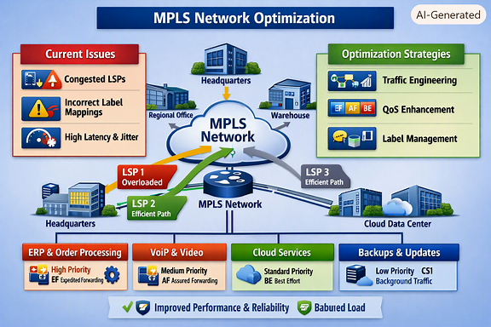

4. A multinational logistics company operates an automated warehouse where barcode
scanners, RFID readers, autonomous robots, and inventory management systems
continuously exchange data over a computer network. Every day, thousands of shipment
records, customer details, and inventory updates are transmitted between warehouse
terminals and the central server. Recently, the company has observed that some shipment
records are arriving with incorrect information, barcode scans occasionally fail, and
inventory quantities in the database do not always match the physical stock. During peak
hours, network monitoring reports an increase in transmission errors caused by electrical
interference, signal attenuation, and network congestion. Although some corrupted frames
are detected and retransmitted, others remain undetected, resulting in incorrect database
entries and delayed order processing. The IT department suspects that the current error
detection and correction mechanisms are not configured efficiently. As the network
engineer, you are assigned to investigate the transmission errors, identify the weaknesses
in the existing error control techniques, and recommend suitable debugging and
optimization strategies to improve the reliability and accuracy of data communication.
Sol..
1️⃣ Error Detection & Diagnosis Tasks
A. Network Performance Analysis
- Monitor transmission error rates using SNMP or network diagnostic tools.
- Identify error patterns — determine if errors occur at specific times (peak hours) or locations (robot zones, RFID areas).
- Check physical layer integrity — inspect cables, connectors, and electromagnetic interference sources (motors, conveyors).
- Measure signal attenuation across long cable runs or wireless links.
- Analyze frame retransmissions and undetected errors in logs.
B. Fault Identification
- Electrical interference → corrupted frames and signal distortion.
- Signal attenuation → weak transmission over long distances.
- Network congestion → delayed or dropped packets.
- Inefficient error control configuration → undetected corrupted data entering the database.
2️⃣ Optimization Strategies
A. Error Detection Techniques
- Implement stronger error detection codes:
  - Replace simple parity checks with Cyclic Redundancy Check (CRC-32) for higher accuracy.
  - Use checksums for multi-frame data validation.
  - Enable frame sequence numbering to detect missing or duplicate frames.
B. Error Correction Techniques
- Adopt Forward Error Correction (FEC) for real-time robotic and RFID communication.
  - Use Hamming codes or Reed-Solomon codes to correct single-bit or burst errors.
  - Configure Automatic Repeat Request (ARQ) for non-real-time data (inventory updates).
- Optimize retransmission thresholds to balance reliability and latency.
C. Physical & Network Layer Improvements
- Shield cables and connectors to reduce electromagnetic interference.
- Use fiber-optic links for high-speed, interference-free communication between servers and terminals.
- Install signal amplifiers or repeaters to counter attenuation.
- Segment the network to isolate high-traffic zones (robots, scanners, terminals).
- Implement QoS policies to prioritize critical data (shipment records, inventory updates).
D. Database Integrity Measures
- Enable end-to-end data verification — compare received data with source checksum before database entry.
- Deploy transaction validation scripts to detect mismatched or incomplete records.
- Schedule periodic data audits to reconcile physical and digital inventory.
3️⃣ Security & Reliability Enhancements
- Encrypt data transmissions to prevent tampering during retransmission.
- Use secure protocols (TLS, HTTPS) for server communication.
- Implement redundancy — backup communication paths and mirrored databases.
- Automate error logging and alerting for immediate corrective action
4️⃣ Root Cause Summary
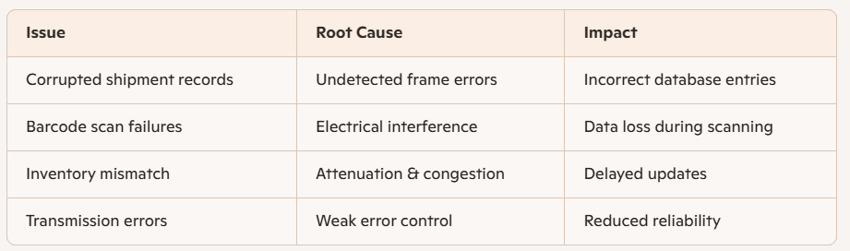
5️⃣ Expected Outcomes
- Accurate and reliable data exchange between warehouse devices and servers
- Reduced transmission errors and undetected frame corruption
- Faster and more consistent barcode/RFID scanning
- Improved synchronization between physical and digital inventory
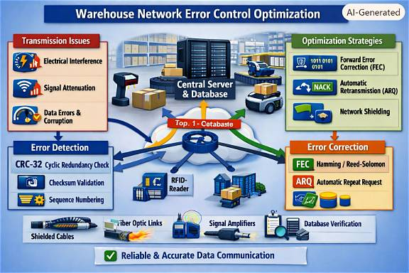
5. A leading online education platform conducts live classes and online examinations for morethan 15,000 students across different locations. During examinations, the central server simultaneously sends question papers, images, videos, and answer submission acknowledgements to all students over the network. The server is equipped with a high- speed 10 Gbps connection, whereas many students access the system using slower broadband or mobile internet connections. During peak hours, students experience incomplete downloads, delayed page loading, duplicate packets, and repeated retransmissions. Some students receive the next set of data before their devices finish processing the previous one, causing receiver buffer overflow and application crashes. Network administrators also observe an excessive number of retransmissions, increased latency, reduced throughput, and poor bandwidth utilization. The current flow control mechanism is not effectively regulating the transmission rate between the sender and receivers. As the network engineer, you have been assigned to investigate the communication problems, identify the causes of inefficient flow control, debug the existing system, and recommend suitable optimization techniques to ensure reliable and efficient data transmission during high-traffic periods.
Sol..
1️⃣ Flow Control Debugging Tasks
A. Performance Analysis
- Monitor network traffic between the central server and student devices using tools like Wireshark or NetFlow.
- Measure retransmission rates, latency, and throughput during peak hours.
- Inspect TCP window sizes and buffer utilization on both sender and receiver sides.
- Identify duplicate packets and incomplete downloads in logs.
- Analyze congestion points — determine if bottlenecks occur at the server, routers, or client endpoints.
B. Fault Identification
- Receiver buffer overflow → students’ devices receive data faster than they can process.
- Excessive retransmissions → inefficient congestion control or packet loss.
- Duplicate packets → poor acknowledgment handling.
- Unregulated transmission rate → sender not adapting to slower client bandwidth.
2️⃣ Optimization Strategies
A. Flow Control Mechanisms
- Implement Dynamic TCP Window Scaling to adjust the sender’s transmission rate based on receiver capacity.
- Enable Sliding Window Protocol for efficient acknowledgment and continuous data flow.
- Use Selective Acknowledgment (SACK) to retransmit only lost packets instead of entire sequences.
- Configure adaptive timeout intervals to prevent premature retransmissions.
B. Congestion Control Techniques
- Adopt modern TCP algorithms such as TCP Cubic or BBR for better throughput under variable bandwidth conditions.
- Enable Explicit Congestion Notification (ECN) to signal congestion before packet loss occurs.
- Implement Quality of Service (QoS) to prioritize exam data and acknowledgments over non-critical traffic.
- Use load balancing across multiple servers or CDN nodes to distribute traffic evenly.
C. Buffer Management
- Optimize receiver buffer size to match device processing capability.
- Enable flow-aware scheduling so the server sends data only when the receiver is ready.
- Use rate-limiting algorithms (e.g., token bucket) to prevent buffer overflow.
- Deploy application-level throttling for large multimedia content (images, videos).
D. Network Infrastructure Enhancements
- Introduce Content Delivery Networks (CDNs) to reduce latency for geographically distant students.
- Upgrade routers and switches to support high-speed queuing and congestion avoidance.
- Implement parallel data streams for large exam files using HTTP/2 or QUIC protocols.
- Monitor bandwidth utilization and dynamically allocate resources during exam sessions.
3️⃣ Reliability & Security Measures
- Encrypt all exam data using TLS to prevent tampering during retransmissions.
- Enable checksum validation for each packet to detect corruption.
- Deploy redundant servers for failover during high load.
- Automate alerts for abnormal retransmission or latency spikes.
4️⃣ Root Cause Summary
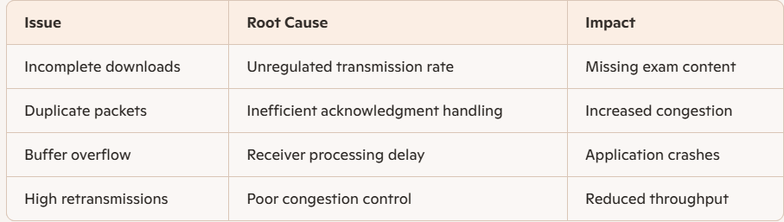
5️⃣ Expected Outcomes
- Stable and efficient data transmission during exams
- Reduced retransmissions and latency
- Balanced server load and improved bandwidth utilization
- Reliable delivery of exam content and acknowledgments
